07/10/2022 12:37:03

07/10/2022 12:37:03

07/10/2022 12:37:03



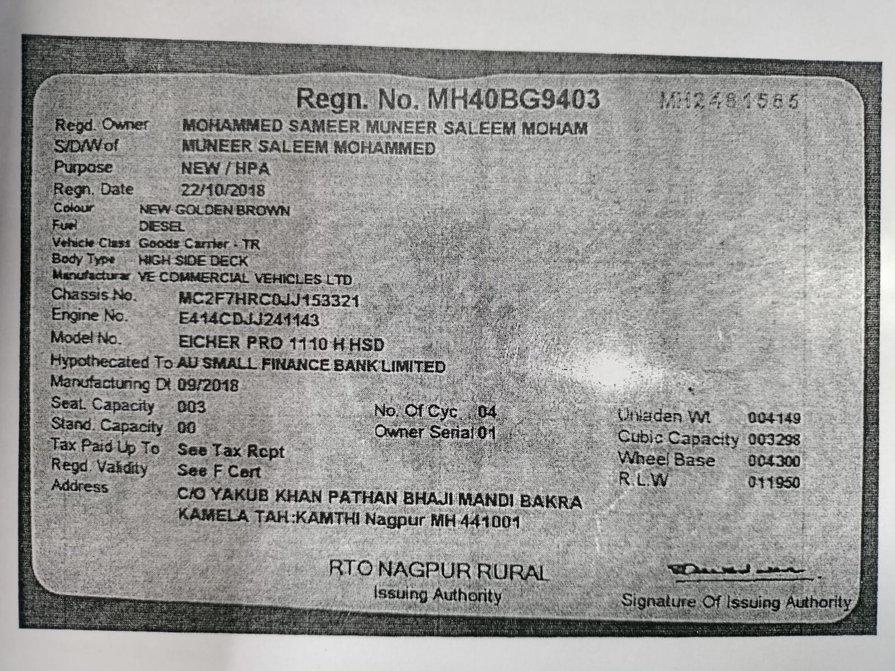

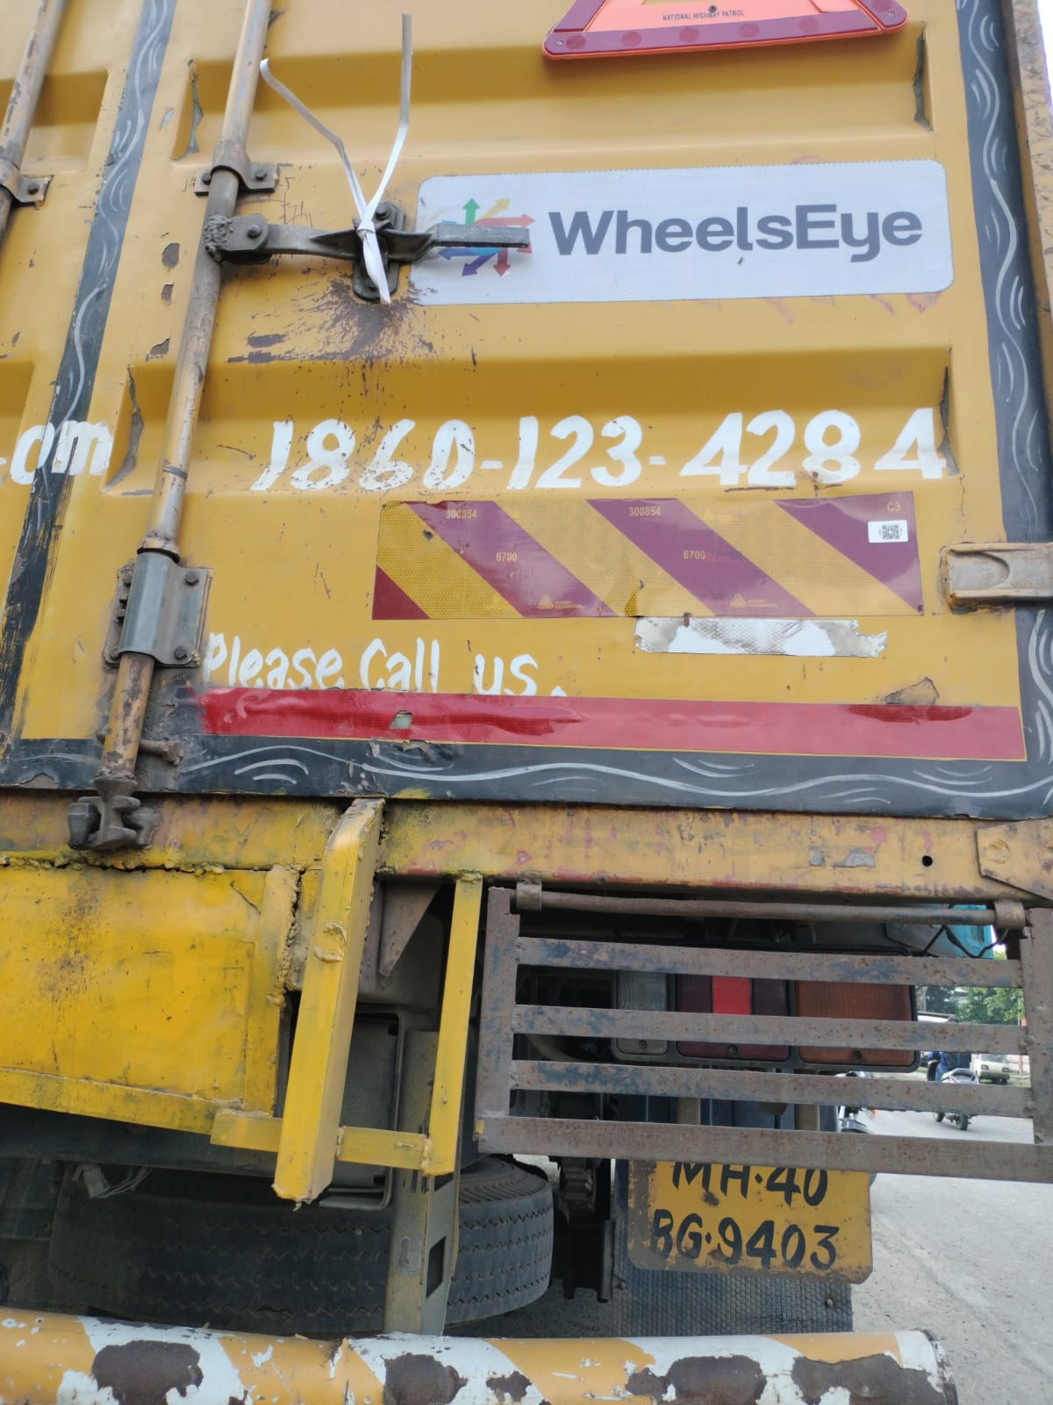

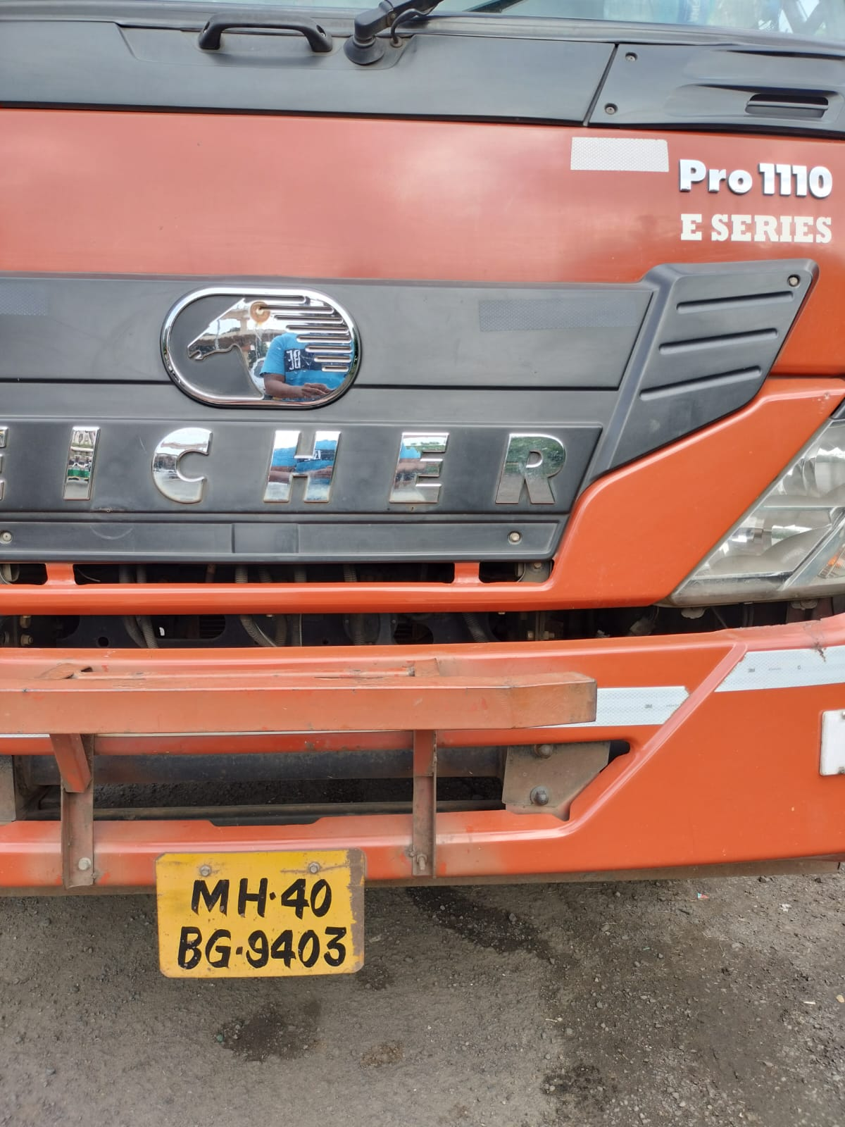



**Installation Certificate**

**SHL/16/2021-2022/7472732485/COP/9254**

**30-09-2023**

Certificate No:

**MH40DM640CTF54EU3C8JVG6ZB4**

**07/10/2022**

Creation Date:

**07/10/2022**

Valid From:

**06/10/2023**

Valid Till:

COP:

COP Valid Till:

**MH40-BG-9403**

Application Details

Product Name

Quality

**CT**

**1**

**Reflectors**

**4**

Vehicle Details

Owner Name

Vehicle Name

**MOHAMMED SAMEER SALEEM MOHAM**

**VE COMMERCIAL VEHICLES LTD**

Vehicle Model

**MGV**

Chassis Number

Mobile Number

**3321**

**9999999999**

Year of Manufacturing

**2018**

Images

FRONT LEFT IMAGE

BACK RIGHT IMAGE

DOCUMENT IMAGE

Dealer Details

Dealer Name :

RTO Location

**MH40**

Declaration

We hereby certify that we have supplied/installed the ARAI approved RRT as per the CMVR rule no 104/104D specified under CMVR GSR

784 (

E) 291 (E

).



IMRAN SOHIL

Trade Lic. No.:

MH-16-TC-218